New Graduate Nurses’ Transition to Clinical Practice:
A Phenomenological Study of Preparation, Transition Shock,
and Early Practice Experiences

Tuesday, May 12, 2026
11:00am – 12:30pm
TEAMS LINK

Presented by:
Valerie V. Whynall

Valerie Whynall’s dissertation explored the lived experiences of new graduate nurses within their first 12-months of clinical practice. Employing a phenomenological methodology, her work explored the transition from student to practicing profession. Utilizing Duscher’s Transition Shock Theory, Valerie examined experiences and reactions of new graduate nurses to becoming a nurse a working independently on the hospital floor – in the hospital. with patients.

Her findings suggest that the process of transitioning to practice is a significant period of personal growth but is also a time of self-doubt and emotional turmoil. External factors such as supportive work environments, clinical preparation and work-life balance play a significant role in the overall experience of the new graduate nurse. Conclusions from this research emphasize the importance of preceptors’ support and for the confidence building of new nurses within the first year of nursing.

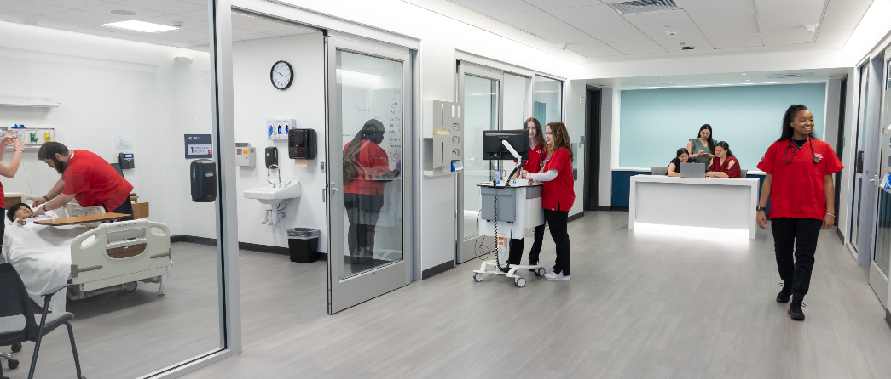

Valerie is a practicing registered nurse and Assistant Professor of Nursing at the University of Hartford. She holds an Associate Degree in Nursing from Saint Paul’s School of Nursing, a Bachelor of Science in Nursing from Northeastern University and a Master of Science in Nursing with a focusing in nursing education from the University of Hartford.

